# Operating Systems 1

## Tanmay Garg CS20BTECH11063

Programming Assignment 1

**Program Design:**

* We first take input from the user from command line which should be a positive integer
* Then we call the fork() system call
* If it is not able to fork() then it gives pid the value less than 0 and throws an error
* If it is able to fork() then it makes pid as 0 and now the child process is working
  + When the child process is started it runs a while loop to begin with the Collatz Conjecture
  + If n is even, $n ←n/2$
  + If n is odd, then n becomes $n←3n+1$
  + The process continues until $n=1$
* In all other situations it calls the wait() system call to wait for the child process to get over
* The child process outputs the list of numbers generated by the Collatz Conjecture

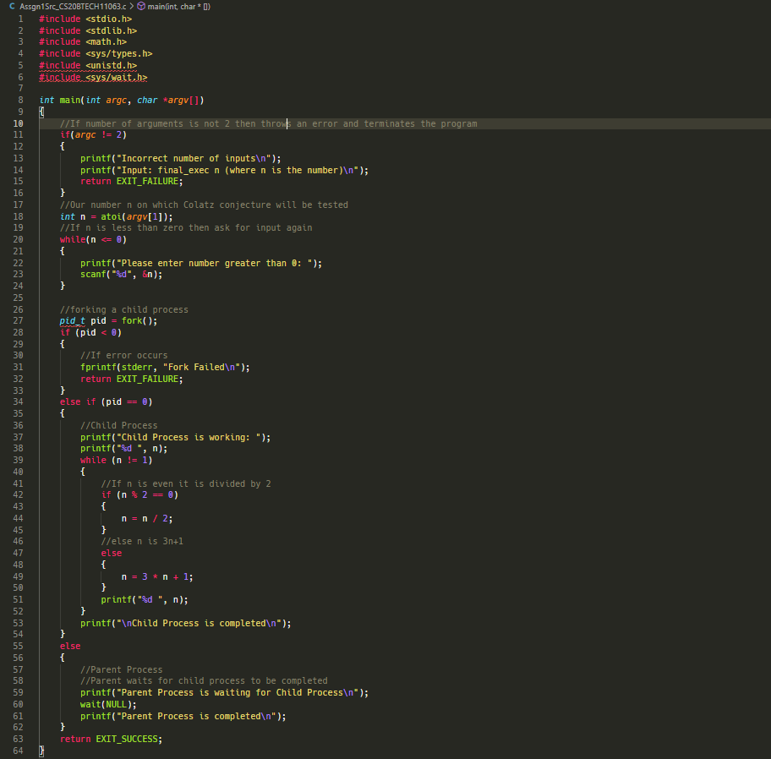

Program Analysis:

* When the program performs fork() it assigns a Process ID to pid
* If the Process ID is 0 then it proceeds to the Child Process
* The Loop performs Collatz Conjecture on the number till it reaches the value 1
* The Program has been tested for different values such as 65, 40, 101 and all of them converge into the series 4, 2, 1
* If the Process ID is greater than 0 then it waits for the child process to be completed
* If the Process ID is less than 0 then it shows an error as the process could not be created and hence returns EXIT_FAILURE
* If the entire program works and gives a proper output, then it simply returns EXIT_SUCCESS
* In the situation when the number of input arguments in command line is not 2 then it throws an error and exits the program such as shown in the demo below
* In the situation when the input number is less than 0 then it throws an error and asks user to input positive number

